Welcome to the 5th Annual Regional Sprint Championships
Pānui 3
Event Information
Race Date: Saturday 12th & Sunday 13th December
Location: Lake Pupuke, Sylvan Park, North Shore, Auckland
Events: W1 and W6 Events

Key Event People
Race Directors: Louise Henderson/Katriona Main
Admin/Registration: Julia.Pua-Tipokoroa
Protest Officer: Julia.Pua-Tipokoroa
Accounts and Admin: Tania Albert
Loading Bay & Marshalling: Cilla Wiki/Tipoki Mitchell
Head Announcer: Steve Harris
On the Water Chief: Sharon Hawke
Waka Rigging: Te Pou Herenga/Te Paerangi
Event Liaison: Tania Albert

Parking
Waka trailers will have allocated parking
W1’s will have an allocated area for those people bringing their waka on Friday between 1pm and 6pm
General parking will be first in, first served, gates have been organised with the council to open at 6am
There is selective parking on Sylvan Park Rd and Pierce Rd.

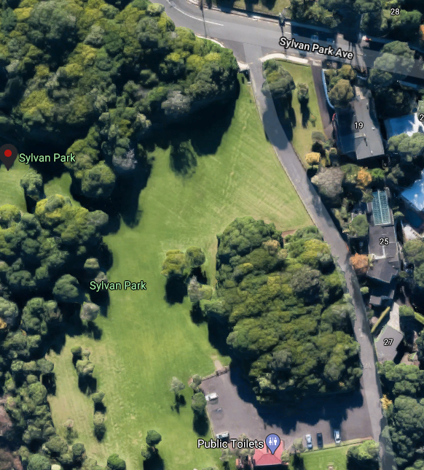
General Parking
W1 – Waka Storage
Waka Trailer Parking

Security
Security will be on site Friday & Saturday from 6pm to 6am.

Racecourse
The lanes are 32meters wide with the flag sitting at 16m in the middle of each lane.
Half lanes are 16m wide, W6 are rigged at 1750mm
There are 4 lanes for turns and 10 lanes for non turns

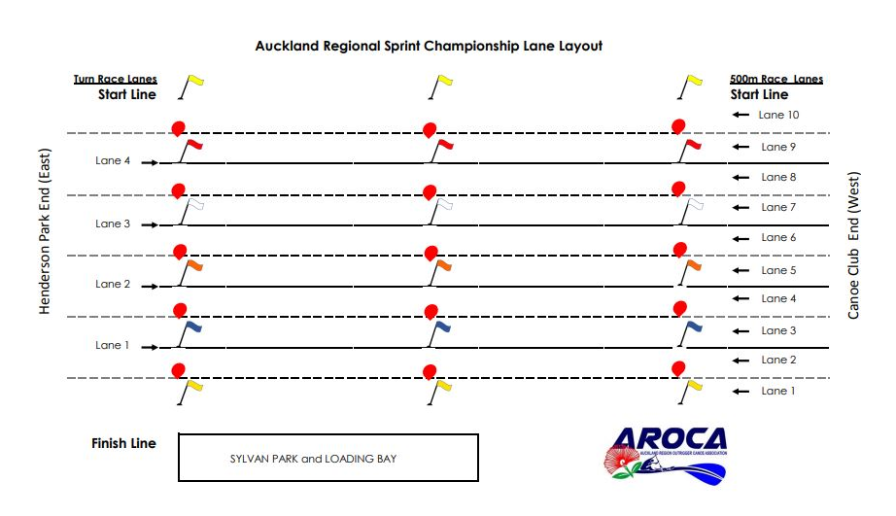

Race Rules
Please ensure you are familiar with the race rules. The latest race rules can be found here
https://www.wakaama.co.nz/pages/read/1005147

Protests
Protests made during the competition must be addressed to the Head Course Judge in writing no longer than fifteen (15) minutes after the particular race has finished or in the case of disqualification, no longer than fifteen (15) minutes after the official posting of the disqualification.

- All protests shall be accompanied by a fee ($100) set by the Organising Committee. The fee is only refundable if the protest is upheld.
- The Head Course Judge shall notify all parties directly involved in the protest.
- Procedure on receiving a protest:
  - If three [3] or more official stations call a disqualification, the protest shall be disallowed by the Head Course Judge.
  - If two [2] official stations call a disqualification, the Head Course Judge may consult with the Protest Committee. The Head Course Judge shall make the final decision.
  - If only one [1] official station calls a disqualification, the Head Course Judge shall call a meeting of the Protest committee. The Protest Committee shall make the final decision.
- The Head Course Judge shall inform all involved parties of the final decision.
House Keeping
Take care of your stuff
Please look after your belongings, do not leave valuables inside tents.

Respect of the venue
Please pass on to your club members and supporters that we must respect the venue.
Nobody wants to see any tagging or vandalism. We would like to leave the venue the way we found it.

First Aid
Each Club should provide their own First Aid Kit, however there will be one based at the Registration area

Lost Property
If you find any lost property, please return it to Registration Desk. And if you are looking for something we are happy to make announcements for you.

Rubbish
We will be using the 3-bin method for rubbish as requested by council, please ensure you put your items in the correct bin and do not leave rubbish lying around

Admin
If you have any queries, please go to the Registration Area. The team will do their best to help you
and if they don’t have the answer they will try and find it from someone who does.
Results
The Results will be posted around the registration ‘block’ wall

WIFI Results
If you have an IPAD or Phone with internet access, you will be able to access WIFI results
throughout the racing. The link is http://liveresults.co.nz/

Bad Weather
Should we experience unsafe conditions we will halt all racing until those conditions have passed.
This is the call of the race director. There will be no racing in the dark

Waka Use
As W6 waka are kindly loaned by clubs, AROCA will fine anyone who stands up in W6. The fine is $100 per individual, per infringement. No exceptions. The cost of the fine will be charged to the club concerned. Respect and care for all waka, paddlers, volunteers, and officials is paramount to the sport.

Any team causing damage to any W6 waka at any time during the event will incur the cost of
the repairs, which will be charged to the team’s club.
All contracted W6 waka are used solely for competition. No contracted waka may be taken or used
for training purposes while contracted to the event; this non-permitted use will incur a fine to the
offenders club of $200 per incident.

Operational Components during the Event

Announcements
Race Announcers will call for teams 2 times.
First Call - Teams should be getting ready and making their way down to the marshalling area
Second and Final Call – Teams should be at marshalling, getting ready to load out
Please ensure you are aware of the races that are being called. If you think you missed a call, go
and ask an official. Better to be too early to the marshalling than too late.

If you have any announcements you would like called out over the loudspeaker system please go
To the registration area and they will pass the message on to the Announcements team

Marshalling
At Marshalling your team will be asked to line up for your race and in your lane
If you are sharing a waka (W1) please let the Marshalling team know

Loading Bay
- Once the paddler has gone through marshalling, the paddler cannot leave the area
- There are port-a-loos provided in the loading bay area.
- Paddlers must know their race number and lane and follow directions
- The Loading Bay volunteers will inform the paddlers when it is their teams turn to load out.
- Highest number lanes load out first (as they have the longest distance to paddle to the
correct start position).
- For turning races, teams are expected to wait in-line for their start.
- Please be careful on the pontoons. They are slippery when wet.

- Do not take valuables down to the Loading Bay. There is no-one charged with watching
your belongings while you are racing.
- On finishing races, paddlers are expected to continue paddling through the waiting canoes.
- Do not stop on the finish-line and dawdle, you will be in the way for the next race start and
cause annoyance.
- On return to the pontoons follow the directions of the loading bay volunteers and smartly return
your canoe.
- Camaraderie and accolades (Hi-5’s, hugs etc) can be done with fellow competitors and
managers away from the Loading Bay
Race Starts
Competitors must be present at the start line for their race as shown on the program. Starting signals shall be given regardless of absentees.
Official boats shall not assist, except in case of an emergency such as a capsize or where officials consider that midget and intermediate paddlers may get into trouble if no assistance is rendered.

The start shall be controlled by the starter(s). There shall be an aligner, located on the side of the racecourse and the flag holder - located in a boat in the middle of the course approximately 60 metres in front of the start line.

The order of the start is as follows:
a. Raising of the white flag indicates the race is in the aligner’s control and
competitors should move up to the false start line
b. Raising of the red flag by the starter (flag holder) indicates to paddlers that they must head to
the start, stop, hold and align
c. Raising of the green flag by the starter (flag holder) indicates the start of the race.

If the bow of a waka is across the start line at the raising of the green flag this shall
result in disqualification or time penalty

If the starter raises a black flag during the starting procedure, this indicates
that an infraction exists and the bow of at least one canoe is across the start line.

Competitors will be given the opportunity to line up correctly. If, after a reasonable
time, the infraction has not been corrected (in which case the black flag will not be
lowered), the race may be started, resulting in disqualification or time penalty of those canoes that
caused the infringement.

If conditions do not permit the starter to align on the marked start line, competitors shall be informed before each race.

Not following starter orders will result in disqualification or time penalty
Should a re-start be called, competitors are to return to the false start line and follow the starter’s instructions.

